

**Financial Insights**

**from The Big Short**

## By Abhishek(240039)

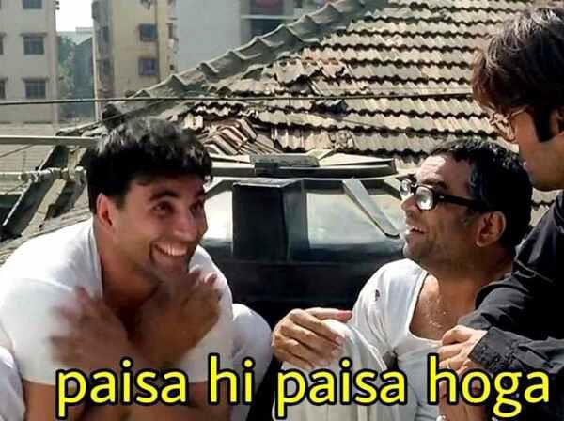

**Why Did i choose Algo-Trading Project?**

## I thought that after learning Algo-trading

**The real answer -**

**I’ve always been intrigued by how markets operate, especially the way algorithms can drive decision-making in trading. The idea that algorithms can analyze massive datasets, identify patterns, and make trading decisions at a speed and scale beyond human capacity is fascinating to me. For this I have also enrolled in an AI/ML course.**

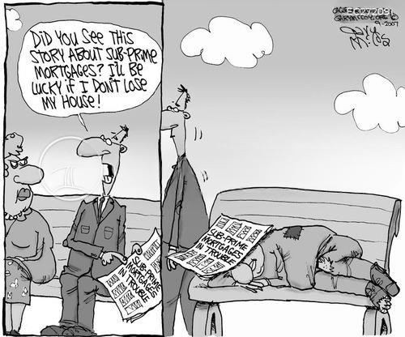

**Key Finance Concepts and Terms**

**Subprime Mortgages**

* What They Are: These are home loans given to borrowers with poor credit scores and high risk of default. Because the borrowers are considered more likely to fail in repayment,

the loans are considered subprime.

* + In the Movie: The film shows how financial institutions began offering these risky loans in

abundance, knowing the high likelihood of defaults, and how these loans helped inflate the housing bubble until it inevitably burst.

**Mortgage-Backed Securities (MBS)**

* + - What They Are: MBS are investments made up of a collection of home loans that have been bundled together. Investors purchase shares of these securities, effectively betting on

the stability of the housing market.

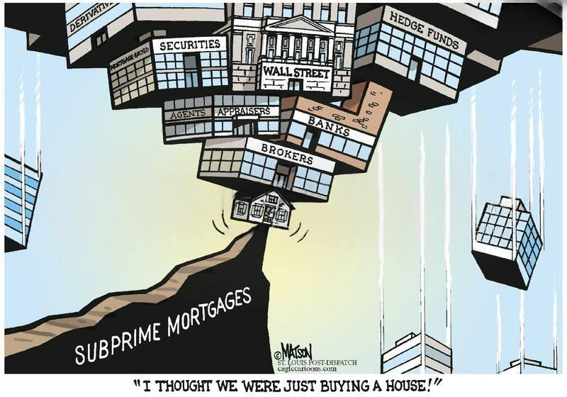

In the Movie: These seemingly safe investments were actually filled with dangerous subprime loans. The characters realize how MBS were sold to unsuspecting investors with inflated credit ratings, only to become worthless when the housing bubble burst.

## Collateralized Debt Obligations (CDOs)

What They Are: CDOs are structured financial products that pool together various debt types (such as MBS) and divide them into different levels of risk. The higher- risk tranches offer larger returns, but they are also more prone to default.

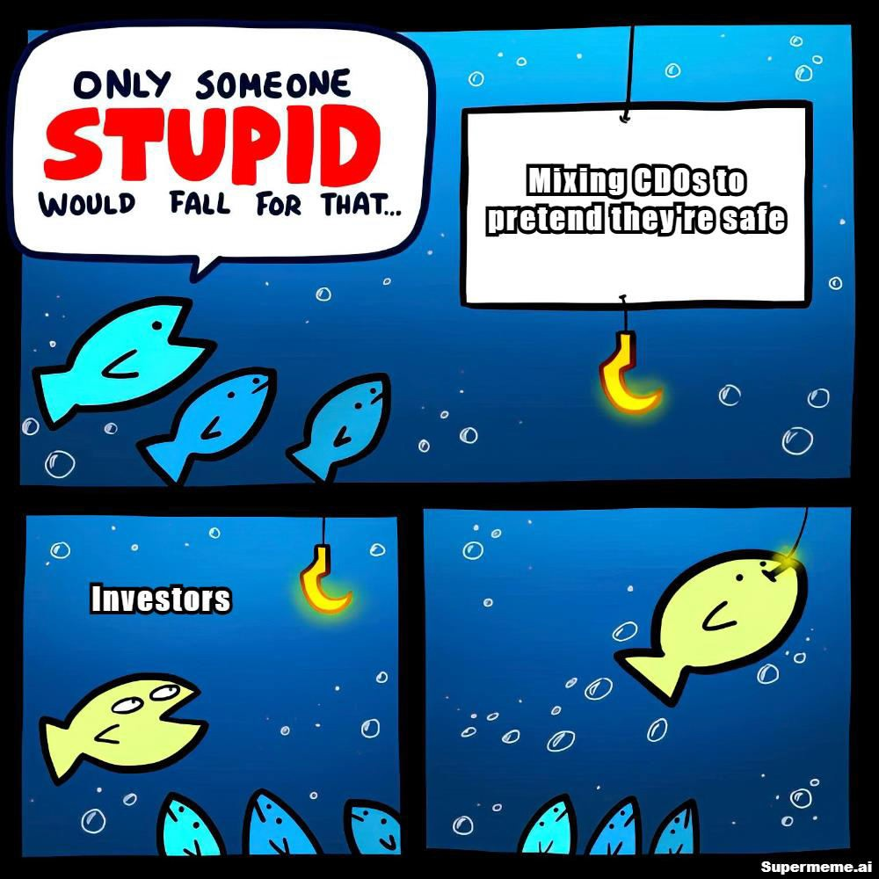

In the Movie: The main characters uncover that many CDOs were composed of bad debt, and despite high ratings, they were essentially ticking time bombs. By shorting them, the characters profited from the eventual collapse.

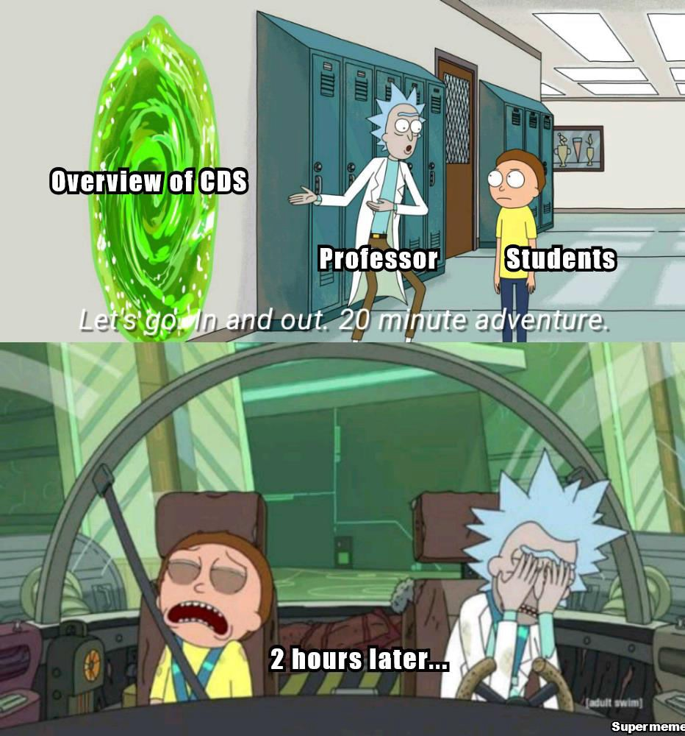

# Credit Default Swaps (CDS)

**What They Are**: CDS are insurance-like financial products that protect investors from the default of other securities, like MBS or CDOs. By purchasing a CDS, an investor bets against the security, betting that it will fail.

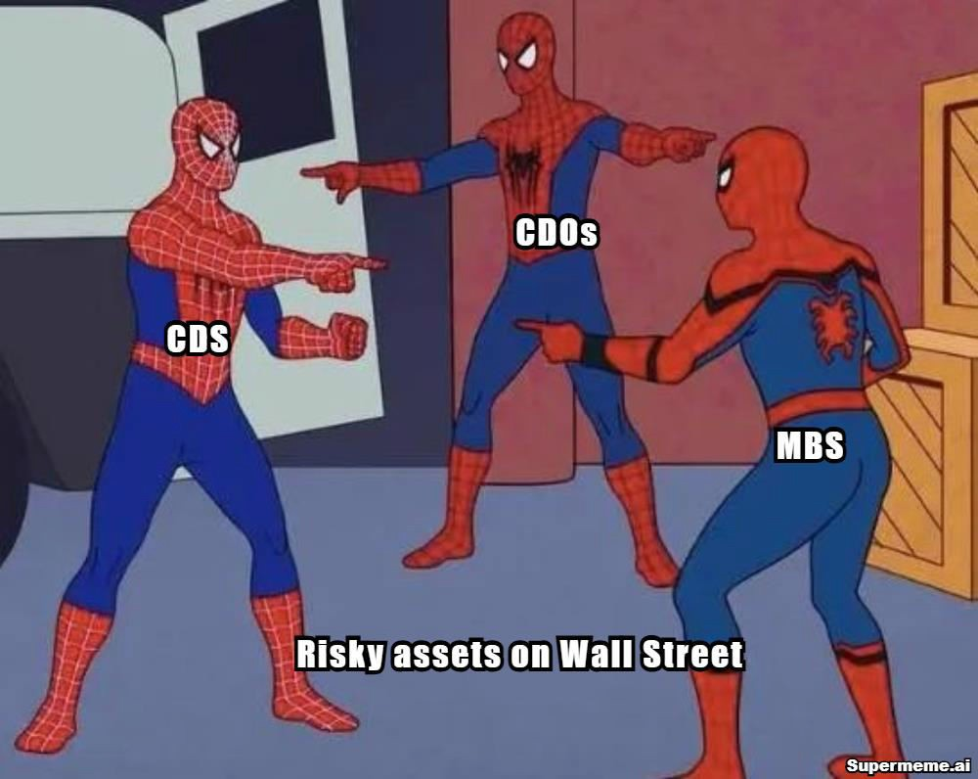

**In the Movie**: The investors in *The Big Short* purchase CDSs to bet against the housing market. These were key to their strategy of profiting from the housing crisis by betting that MBS and CDOs would collapse.

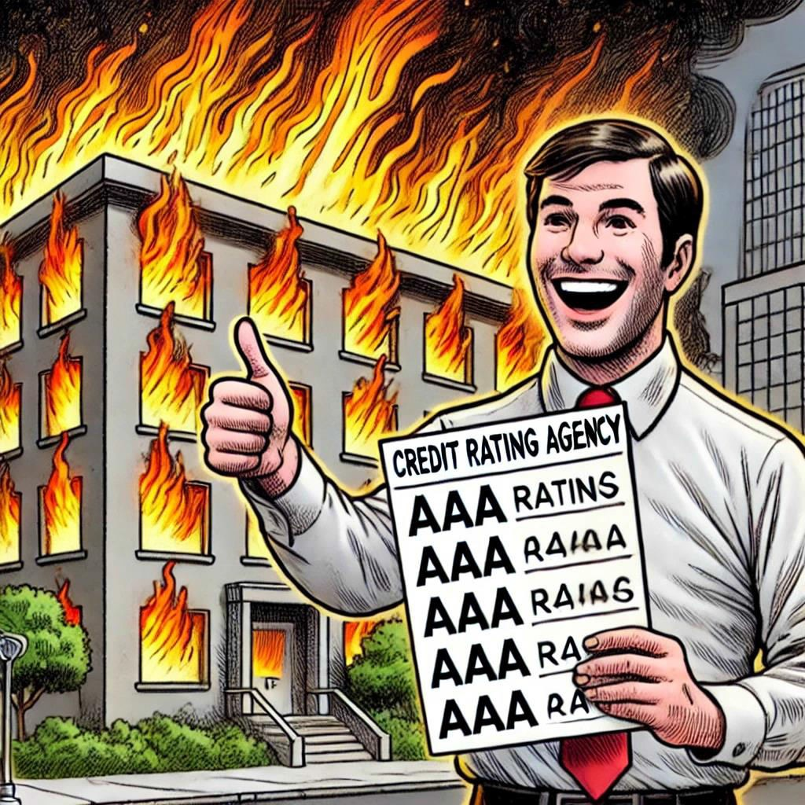

# The Rating Agencies (Moody’s, S&P, Fitch)

### **What They Are**: These agencies evaluate the risk of financial products and assign ratings based on their potential for default. These ratings are relied upon by investors when assessing the safety of investments.

**In the Movie**: The film critiques how these agencies were complicit in the crisis by giving high ratings to risky securities like MBS and CDOs. Their inaccurate assessments misled investors and contributed to the collapse.

**Synthetic CDOs**



**In the Movie**: The characters in the film discover synthetic CDOs, which were built using risky

financial derivatives, further exacerbating the problem and inflating the financial bubble.

**What They Are**: Unlike traditional CDOs, synthetic CDOs don’t rely on actual debt like mortgages. Instead, they derive their value from credit default swaps. These are incredibly risky and can be highly profitable when they work, but they also increase the financial system’s overall exposure to risk.

# The Housing Bubble

### **What It Is**: Leverage refers to borrowing funds to invest in assets, amplifying both potential returns and risks. High leverage means greater potential profits, but also greater chances of loss.



**In the Movie**:

### *‘The Big Short’* showcases how the housing market was artificially inflated due to excessive lending, which ultimately led to a collapse that triggered the global financial crisis.

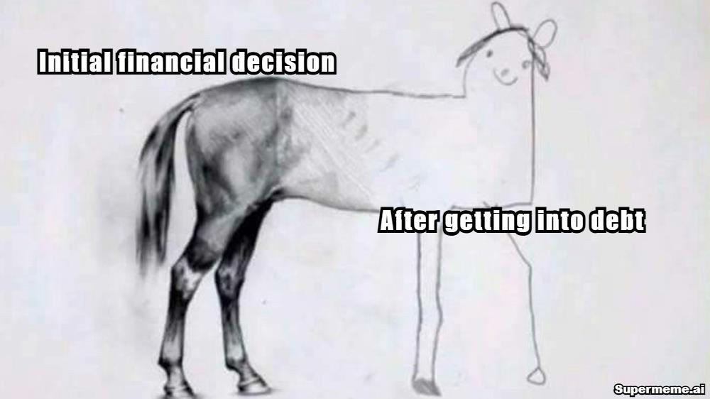

**Leverage**

**What It Is**: Leverage refers to borrowing funds to invest in assets, amplifying both potential returns and risks. High leverage means greater potential profits, but also greater chances of loss.

**In the Movie**: The film demonstrates how financial institutions and investors took on massive amounts of debt to buy risky securities. When the market crashed, their leverage caused catastrophic losses, amplifying the scale of the crisis.

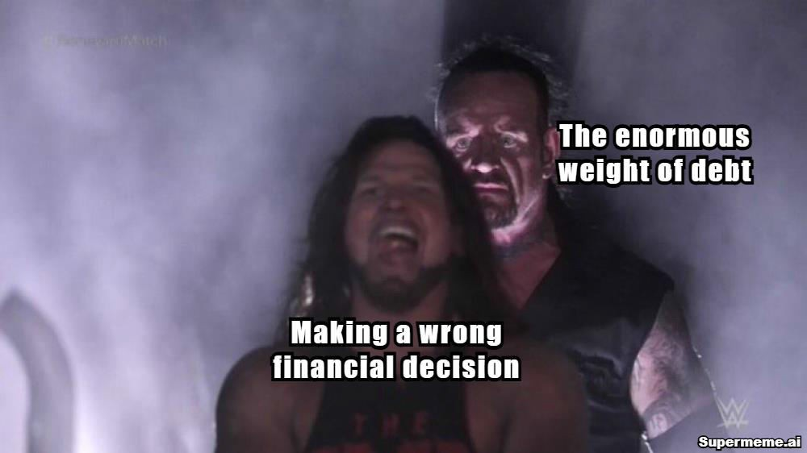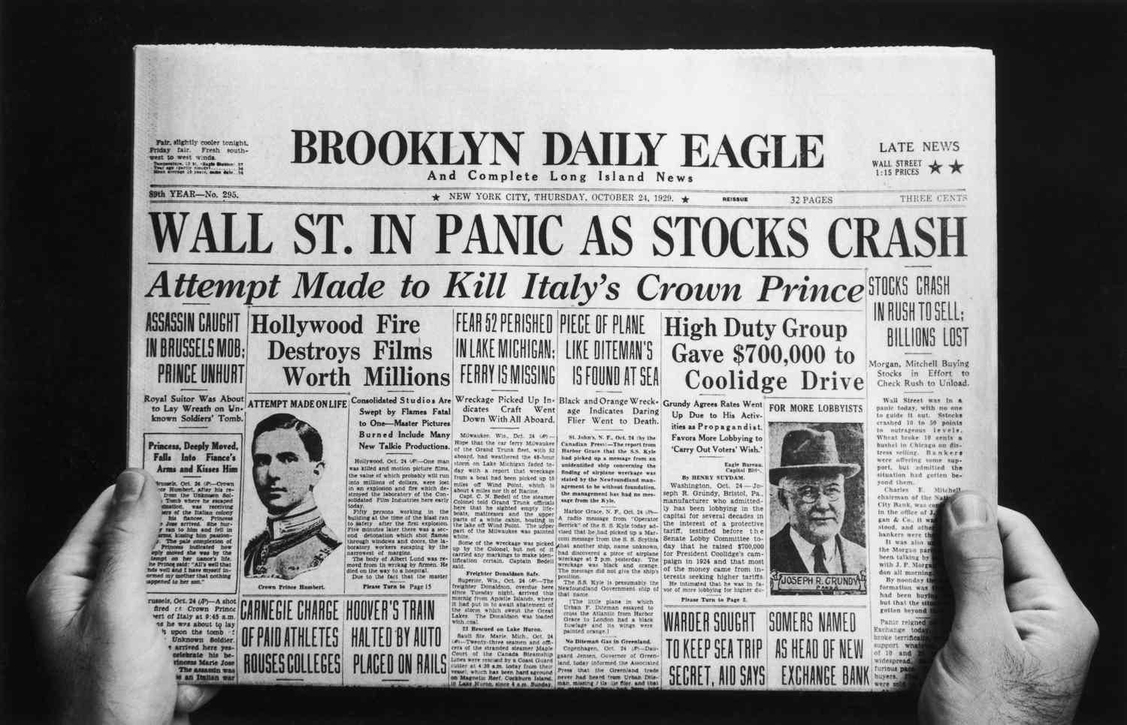

# Wall Street and "The System"

**What It Is**: Wall Street is a symbol of the financial industry, where banks, hedge funds, and financial institutions operate. The system refers to the interconnected nature of these institutions and their influence on the global economy.

**In the Movie**: The movie critiques Wall Street’s practices, showing how banks and other players in the system engaged in reckless behavior to make profits, all while knowing that their actions would have catastrophic consequences for others.

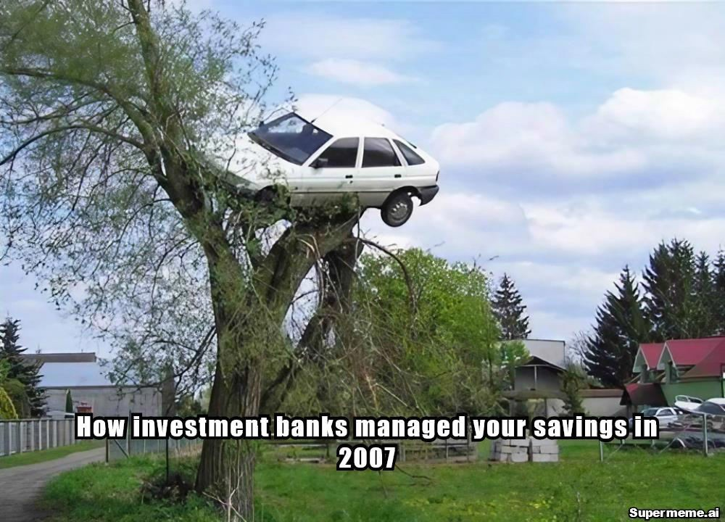

# Systemic Risk



**What It Is**: Systemic risk refers to the potential collapse of an entire financial system due to the failure of a major player or sector. The 2008 financial crisis is a classic example of how one failing market (the housing sector) can trigger a global economic meltdown

**In the Movie**: The movie highlights how the collapse of the housing market didn’t just impact homeowners—it caused a cascading failure across the entire financial system, leading to a global recession.

**Something Funny I Learned from *The Big Short***



### One of the funniest moments in the movie involves Margot Robbie explaining complex financial terms while lounging in a bathtub. She uses a pool of water to explain mortgage- backed securities, illustrating how things can go wrong when you pile too much risk into one place.

* Sometimes, the most complicated financial terms can be simplified with metaphors or humour. The bathtub scene made it clear that financial concepts don’t have to be as dry or intimidating as they seem—sometimes they just need a good analogy to make sense

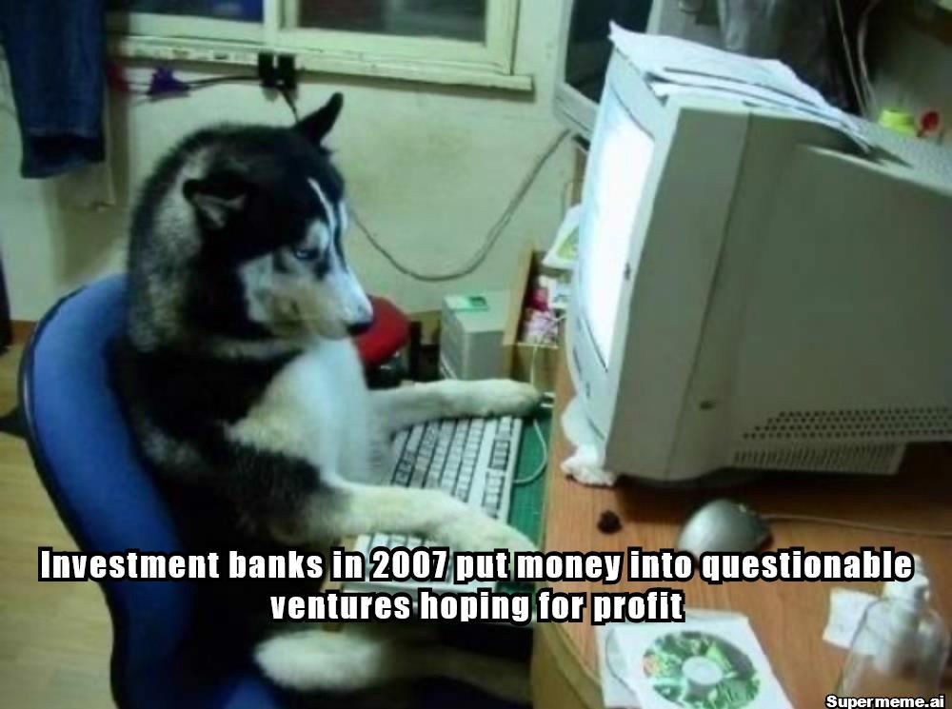

PERSONAL VIEW

Watching The Big Short opened my eyes to the intricacies and dangers of the financial system. It became clear that many of the problems that led to the 2008 crash were a result of greed, lack of regulation, and a complete disregard for the broader economic consequences. The film not only shed light on the causes of the financial crisis but also highlighted the importance of financial literacy and transparency, something that is crucial for anyone working in the finance industry

Thank You